


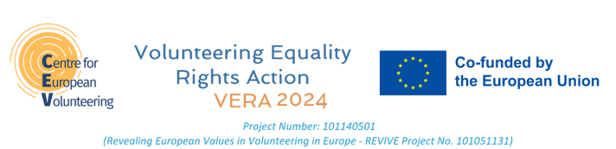


CONTEXT

This pledge is to show the MEP candidates’ support to establish the Intergroup on Civic Engagement and Volunteering in the European Parliament and needs to be sent directly from the CEV Members Organisations to the candidates,, receive them back and send them to the CEV secretariat.

INSTRUCTIONS
- Contact the MEP candidate

- Send the second page of this Pledge Document

- Get it back signed by the MEP candidate

- Convert it to PDF

- Name it: (Country)_(MEP Name)_VVV_Pledge_2024

- Send it to joseph@cev.be

PLEDGE

Io sottoscritto/a(nome)............................................................................................
Candidato/a al Parlamento europeo........................................................................
member of group (select) EPP / S&D / Renew Europe Group / The Greens,EFA /
GUE,NGL in the European Parliament, dichiaro il mio sostegno alla missione e ai valori di CEV e che, in caso di elezione come membro del Parlamento europeo nel giugno 2024, mi impegno a sostenere e promuovere l'istituzione di un intergruppo del Parlamento europeo sull'impegno civico e il volontariato.

I declare full adherence and respect for the fundamental principles of human rights and democracy enshrined in the Art.2 of the Treaty on European Union. I understand that the campaign promoters reserve the right to decline pledges from candidates who are deemed not to uphold such principles.

Firmato:
Timbro:

Data e luogo:

Recapiti
Telefono:
Email:
Social media:

